**The use of rolling benchmarks within the JD Tracker**

Since the launch of the Johne’s Disease (JD) Tracker tool in July 2021 the colour coding (benchmarks) have been based on data collated in 2020 from 253 herds (Table 1). However, as the JD situation in herds across Great Britain (GB) has improved, these benchmarks have become outdated, and now with the launch of Phase III of the National Johne’s Management Plan (NJMP) on March 31st 2025 it is time to refresh themAs shown in Figure 1, based on data from quarterly testing herds within the National JD Tracker database, the benchmarks generated in 2020 now categorise 75%, 12%, 6% and 7% of quarterly testing herds as being in quartiles 1, 2, 3 and 4, respectively, demonstrating the huge progress made in Johne’s management since 2020.

From 31st March 2025, benchmarks within the JD Tracker tool will be recalculated and updated annually using 3-year rolling averages (Table 1, Figure 2). For example, the 2024 rolling averages were calculated using the median values from 2022, 2023 and 2024. These changes will result in the majority of herds observing changes in colour coding across multiple JD Tracker parameters.

For example, based on data from quarterly testing herds within the National JD Tracker database, an estimated 31.7% of herds will shift 1 quartile (1 – 2, 2 – 3 or 3 – 4) and 36.8% of herds will shift 2 quartiles (1 – 3, 2 – 4) for average test value (ATV).

**Importantly, the values within the JD Tracker Tool will remain the same, only the colour coding (benchmarks) will change.**

Farmers seeing a change in colour for any parameters should not be disheartened. It doesn’t mean that Johne’s in that herd has got worse, it is just a reflection of where that herd sits amongst the full cohort of quarterly testing herds.

What is most important is how your herd is progressing and that the overall trend is showing all parameters moving in the right direction.

The fact that the industry has moved Johne’s control forward to the extent that we need to update the Tracker parameters is great news. Now we can use the new figures to drive Johne’s management on again.

**Table 1.** Comparison of 2020 and 2022 – 2024 rolling benchmarks.

|  |  |  |  |  |  |  |
| --- | --- | --- | --- | --- | --- | --- |
| **JD Tracker Parameters** | **Annual 2020 benchmarks** | | | **Rolling benchmarks**  **2022 to 2024** | | |
| **Q1** | **Median** | **Q3** | **Q1** | **Median** | **Q3** |
| AveTVal | 7.54 | 9.23 | 10.82 | 4.54 | 5.81 | 7.60 |
| pPOS | 2.90% | 4.70% | 6.50% | 0.97% | 1.99% | 3.72% |
| pPOS60 | 0.70% | 1.40% | 2.70% | 0.16% | 0.63% | 1.46% |
| pPOS100 | 0.00% | 0.40% | 1.10% | 0.00% | 0.19% | 0.66% |
| pJ4 | 1.60% | 2.40% | 3.20% | 0.55% | 1.06% | 1.82% |
| pP1J4 | 0.90% | 1.80% | 3.00% | 0.08% | 0.72% | 1.60% |
| pJ5 | 2.20% | 3.80% | 5.90% | 0.56% | 1.52% | 3.11% |
| pPrCulls |  |  |  | 0.04% | 0.58% | 1.46% |
| RRservJ5 | 0.24 | 0.55 | 0.80 | 0.00 | 0.36 | 0.74 |
| RRexitJ5 | 4.06 | 2.69 | 1.81 | 1.80 | 3.13 | 5.04 |

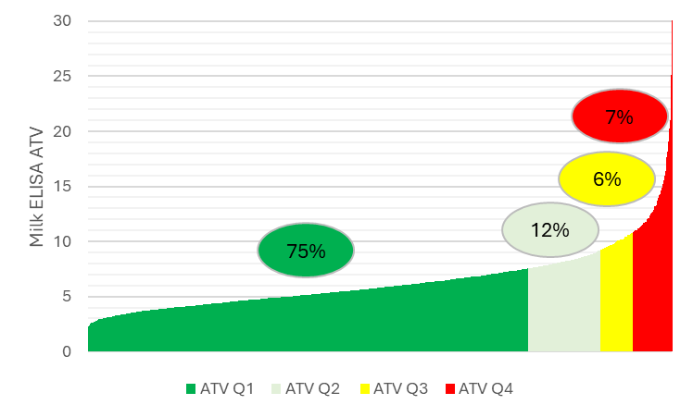

**Figure 1**. The proportion of quarterly testing herds within the National JD Tracker database within each quartile within the 2024 calendar year based on 2020 benchmarks .

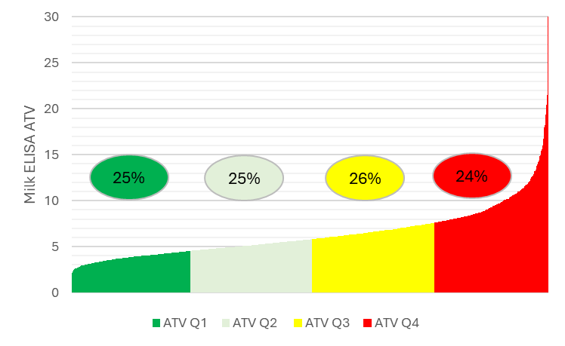

**Figure 2**. The proportion of quarterly testing herds within the National JD Tracker database within each quartile within the 2024 calendar year based on a 3-year rolling average (2022 to 2024).

**Table 3**. Case studies showing the effects of changing the JD Tracker benchmarks on the colour coding within the JD Tracker tool.

|  |  |  |  |  |  |  |  |  |  |  |
| --- | --- | --- | --- | --- | --- | --- | --- | --- | --- | --- |
| **Benchmarks** | **AveTVal** | **pPOS** | **pPOS60** | **pPOS100** | **pJ4** | **pP1J4** | **pJ5** | **pPrCulls** | **RRservJ5** | **RRexitJ5** |
| 2020 | 5.5 | 3.1% | 0.0% | 0.0% | 2.7% | 2.2% | 0.7% | 0.3% | 0.0 | 2.5 |
| 22-24 | 5.5 | 3.1% | 0.0% | 0.0% | 2.7% | 2.2% | 0.7% | 0.3% | 0.0 | 2.5 |
|  |  |  |  |  |  |  |  |  |  |  |
| **Benchmarks** | **AveTVal** | **pPOS** | **pPOS60** | **pPOS100** | **pJ4** | **pP1J4** | **pJ5** | **pPrCulls** | **RRservJ5** | **RRexitJ5** |
| 2020 | 7.5 | 4.4% | 2.0% | 0.7% | 1.2% | 1.5% | 5.6% | 3.5% | 0.8 | 3.0 |
| 22-24 | 7.5 | 4.4% | 2.0% | 0.7% | 1.2% | 1.5% | 5.6% | 3.5% | 0.8 | 3.0 |